State-of-Art Nonlinear Electronic Design Automation Tools for Microwave/RF Circuit Analysis
José Carlos Pedro

Resumo - O presente artigo apresenta o estado-da-arte das técnicas de análise e simulação de circuitos de RF e microondas. Esta compilação é o resultado do trabalho de preparação das Provas de Agregação do seu autor, bem como de posteriores seminários apresentados sobre o assunto.
Usando uma abordagem que se pretende pedagógica, o artigo começa por estabelecer o problema da simulação de circuitos não-lineares de um ponto de vista geral e teórico. De seguida, a apresentação das várias técnicas é iniciada pelos métodos do domínio do tempo, porque, decorrendo da forma natural com que percebemos o comportamento dos circuitos, são, por isso, os mais intuitivos. Os métodos do domínio da frequência são depois apresentados com o objectivo de colmatar algumas das desvantagens dos primeiros. Finalmente, descrevem-se as mais recentes técnicas multi-cadência mostrando como podem vir a constituir uma forma revolucionária de simular circuitos não-lineares.

Abstract - This paper presents an overview of state-of-the-art techniques for the analysis and simulation of microwave and RF nonlinear circuits. It is the result of the work done for preparation of “Provas de Agregação” (the habilitation degree for full professorship in Portuguese Universities) of its author, and the various seminars given on this subject.
Using a pedagogical approach, the paper first states the problem of nonlinear circuit simulation, as seen from a theoretical viewpoint. Then, it starts the presentation by the most natural and intuitive time-domain methods. Frequency-domain techniques are then introduced as a means to circumvent the most important disadvantages of time-marching engines. Finally, multi-rate techniques are addressed, and it is shown how they can become one of the most important breakthroughs of circuit simulation.

I. Introduction
The specificity of nonlinear RF circuits is pushing the advancement of new circuit analysis methods and simulation techniques from the infancy of analog circuit simulation. In a few simple words, we could say that while traditional SPICE like programs [1], [2] were conceived to handle nonlinear circuits by integrating their transient response in time-domain, and linear circuits by computing their steady-state response in the frequency-domain, RF circuit simulation typically demands for direct nonlinear solvers of the steady-state response under a periodic excitation. So, not only the conventional steady-state methods based on the integration of the transient response are inefficient, as the application of frequency-domain techniques are compromised by the presence of nonlinearity.
On another different aspect, microwave and RF circuits added a new range of distributed elements, like transmission media and their discontinuities, in which the spatial dependence of voltages and currents showed to be orthogonal to what time-marching engines could handle.
However, thirty years of evolution turned today’s nonlinear microwave/RF circuit simulators into powerful tools capable of integrating, in a single software package, time-domain transient engines, time-domain and frequency-domain steady-state periodic solvers, or even any combination of these.
The main objective of this paper is to conduct a brief voyage through the showcase of these tools, in a simple but pedagogical way. Actually, we will always benefit the conceptual underlying ideas behind the various methods, against some of their more advantageous implementations.
Just to give a glimpse to what will be described next in more detail, we should start by saying that most of the circuit simulation problems above formulated can already be tackled by the nowadays-standard nonlinear RF and microwave circuit simulator tool: The Harmonic-Balance technique, HB [3]. In its more usual implementation it handles the linear sub-circuit in frequency-domain, treating, this way, any kind of (linear) lumped or distributed component, and the rest of (lumped and algebraic) nonlinear elements in time-domain [4]. Because it operates simultaneously in time and frequency-domains, HB must rely on a domain transformation tool, usually the discrete Fourier transform, DFT. Unfortunately, this restricts HB applicability to periodic, or at least quasi-periodic, signals amenable for a common DFT, or a multi-dimensional DFT representation [5]. So, although it is quite popular for simulating circuits driven by stereotype forcing functions as single-tone or two-tones, it has been difficult to apply to real telecommunication signals.
This opened a new field of RF and microwave circuit simulation tools capable of meeting these practical engineering needs, whose most notorious implications were a renewed interest for the ancient time-domain transient methods (or, eventually, hybrid-combinations of time and frequency-domain techniques), and a revolution in the way we now see circuit analysis [6]. Actually, the circuit solution is no longer necessarily considered as progressing according to a natural time variable, but, for these modulated excitations, considered as evolving in a multi-rate space of new artificial time variables.
These multi-rate techniques [6]-[10] consider that the envelope and the carrier are uncorrelated, as if they evolved in two orthogonal time scales. Then, they convert the original circuit model of an ordinary differential equation, ODE, in natural time, into another multi-rate partial differential equation, MPDE, in those artificial time variables. Since, typically, the envelope is aperiodic, while the carrier is a sinusoid (or at least a periodic signal), their most common implementation treats the aperiodic information envelope as a time-varying signal modulating a frequency-domain representation of the RF carrier. This way, multi-rate methods take profit of the advantages of both time-domain and frequency-domain techniques.

II. Stating the Nonlinear Circuit Simulation Problem From a Theoretical Viewpoint
In order to get a common framework for the presentation of the various RF circuit simulation algorithms, let us take a simple nonlinear network like the one depicted in figure Fig. 1.

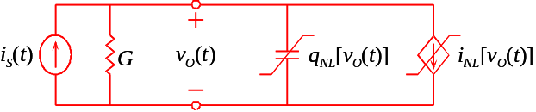
Fig. 1 - Nonlinear dynamic circuit example.
Although very simple, this circuit already includes many of the features encountered in real analogue or microwave/RF circuits. In fact, the application of Kirchoff’s currents law to its single node leads to the following nonlinear ODE in time:

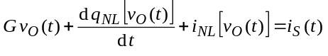 (1)

which can be understood as a particular one-dimensional implementation of a more general model of a nonlinear dynamic (i.e. showing memory) system. Such model expresses the circuit state variable vector, x(t), [in our case the single node voltage v_{O}(t)] in implicit form, as dependent, in a nonlinear way, on its past, dx(t)/dt, d²x(t)/dt²,…, the excitation vector, e(t) [i_{S}(t), in (1)] and the past of the excitation, de(t)/dt, d²e(t)/dt²,…. :

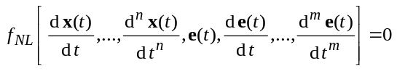 (2)

Such a model is, indeed, capable of modelling a wide variety of circuits.
For example, it could easily represent an autonomous circuit (an oscillator) if e(t) and all its time derivatives were made zero.
It could handle nonlinear inductors if we realize that they are nothing but the dual of the considered nonlinear capacitor. In that case we would express the voltage across the inductor as the time-derivative of a magnetic flux (dual of storage charge) nonlinearly dependent on the inductor current (dual of voltage).
Finally, as we will clear from frequency-domain methods, this model could even represent linear distributed elements.
However, for the sake of being faithful to the truth, we should also say that, although applicable to the vast majority of circuits and elements found in practice, the form of (1) is still lacking some features for being absolutely general [11]. In fact, not only it can not treat distributed nonlinearities, as it even can not handle truly nonlinear dynamic elements. Actually, we might think that the nonlinear capacitor (or the nonlinear inductor) are already instances of nonlinear dynamic elements, but they are not. They are simply memoryless nonlinearities (static charge or flux whose dependence on voltage or current is nonlinear but algebraic) followed by a dynamic, but linear, operator, the time derivative.
This type of nonlinear model, usually known to be based on the so-called quasi-static approximation (semiconductor charges are supposed to react instantaneously to the applied time varying electric fields), is actually the way every modern device model is nowadays commonly formulated. So, and unless some theoretical problems are considered, (1) is already sufficiently general, and we will keep it for the following discussion.

III. Time-Marching Techniques

A. Time-Step Integration
Time-step integration constitutes the base of all time-marching [12] methods. It solves the circuit’s ODE of (1) for v_{O}(t) transforming it into a difference equation. For that, continuous time is discretized in various instants t_{k} separated by dynamic time-steps h_{k}, and the time-derivative is approximated by a difference ratio:

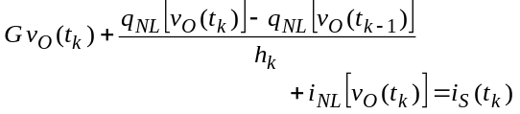 (3)

or

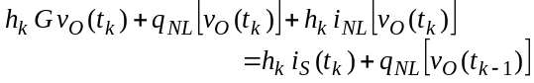 (4)

Then, this nonlinear difference equation is solved in a time-sep by time-step basis, for all v_{O}(t_{k}), beginning with some predefined initial state v_{O}(t₀) until the desired final time v_{O}(t_{K}) is reached.
Since this time-step integration scheme was conceived for transient response calculations, its direct application to the RF steady-state response becomes very inefficient, requiring that we wait until all transients have died [2]. It is also inadequate, since it works in time-domain, while most RF signal and circuit models are represented in frequency-domain. Finally, it is also inaccurate because the use of the DFT requires interpolation and re-sampling between the non-uniform dynamic time-steps, and the need for the ideal complete vanishing of all transients [2].
Nevertheless, time-step integration is still one of the mostly used methods of nonlinear circuit and system simulation. It is the core method of all SPICE-like [1] circuit, or Simulink [13] system simulation programs.

B. Shooting-Newton
In order to overcome most of the above disadvantages associated with time-step integration, shooting methods calculate directly the steady-state response in time-domain. They bypass the transient computation selecting a certain initial condition, v_{O}(t₀), such that, after the excitation period, T, the same initial state is obtained [2]:

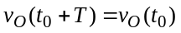 for 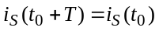 (5)

The underlying idea consists in evaluating the sensitivity of the final state, v_{O}(t₀+T), to variations of the initial condition, v_{O}(t₀):

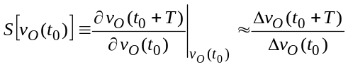 (6)

and then use this sensitivity to propose an educated guess for the correct initial condition v_{O}(t₀) [14]. That is, this method converts the nonlinear transient initial value problem of (3) and (4) into the new nonlinear periodic boundary value problem of (5), which is then solved for v_{O}(t₀+T) = v_{O}(t₀) using a Newton-Raphson iteration scheme, that, as is known, is based on a first order Taylor series approximation of the nonlinear function:

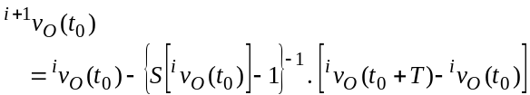 (7)

To calculate the sensitivity, we should first realize that the chain differentiation rule imposes that, since φ[v_{O}(t₀),T]≡φ[v_{O}(t₀),t_{K}] {where φ[v_{O}(t₀),T]=v_{O}(t₀+T), and φ[v_{O}(t₀),t_{k}] is known as the phase transition state of v_{O}(t₀) into v_{O}(t_{k}) [2]} is a function of φ[v_{O}(t₀),t_{K-1}], which, itself, also depends on φ[v_{O}(t₀),t_{K-2}], and so forth; the desired sensitivity, ∂φ[v_{O}(t₀),T]/∂v_{O}(t₀), can be given by:

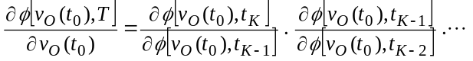
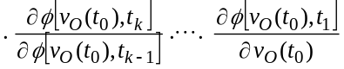
(8)
or

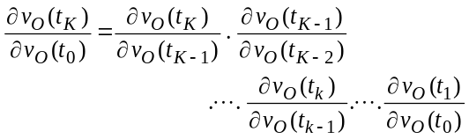 (9)

Now, recalling the time-step iteration scheme, which states that any state v_{O}(t_{k}) can be calculated from the previous one v_{O}(t_{k-1}) by solving

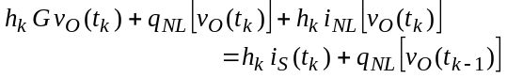 (10)

we can easily compute all derivatives of (9) along the time-step integration process, because ∂φ[v_{O}(t₀),t_{k}]/∂φ[v_{O}(t₀),t_{k-1}] can be obtained by simply deriving (10) with respect to v_{O}(t_{k-1}):

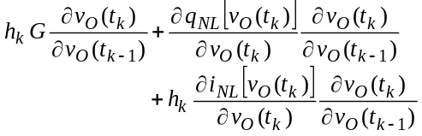 (11)
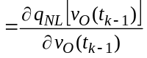
or

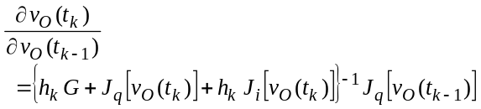 (12)

where J_{q}[.] and J_{i}[.] are the charge and current entries of the Jacobian, computed when solving (4) using the Newton-Raphson iteration.
This combination of a shooting method with the Newton-Raphson iteration scheme is known as the Shooting-Newton. It constitutes an important means of RF steady-state simulation in time-domain. Actually, its efficiency is the result of the calculation of the sensitivity along with time-step integration - without the need for any additional post-processing -, and because it has been verified that the boundary-value equation v_{O}(t₀+T)-v_{O}(t₀)=0 is usually mildly nonlinear, despite the circuit may be pushed well into strongly nonlinear regimes [2].
Just for completeness, we could also mention some other alternatives to time-domain simulation. One involves the use of wavelet expansions of the circuit’s transient response [15], while the other is a relaxation solution of the boundary value problem formulated for periodic regimes [2].

IV. Frequency-Domain Methods
In the same way SPICE treats linear dynamic circuits, the conventional RF approach to solve our original nonlinear ODE for the periodic steady-state, takes profit of the special property of Fourier expansions in converting differential equations into much simpler algebraic formulations. Therefore, the objective ceases to be a set of time points of the output, but a vector of coefficients of the Fourier expansion. So, both the excitation and the state-variables are represented as truncated Fourier series:

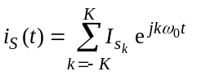 and 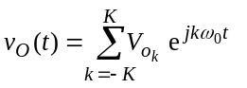 (13)

which, substituted in the circuit’s time-domain ODE of (1), leads to:

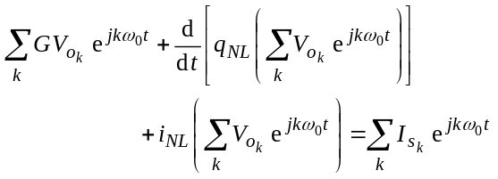 (14)

in which it was assumed all summations span from k=-K to k=K. Because terms of Fourier series are orthogonal, (14) actually corresponds to a nonlinear system of (2K+1) independent equations, one for each harmonic component k. In matrix form, this system is known as the Harmonic-Balance Equation:

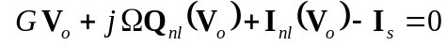 (15)

There are basically two alternative ways of solving this HB equation for V_{o}, the Volterra Series and the Harmonic-Newton.

A. Volterra Series
Starting with the Volterra series, it is assumed that the problem is only mildly nonlinear, so that the circuit’s response can be approximated by the analytical solution of a similar problem in which the nonlinearities are substituted by low order polynomial expansions around some pre-defined quiescent point [12], [16], [17]. In this sense, the recursive nonlinear model of (2) is substituted by a non recursive approach, where the output is given as a (m+1)-dimensional nonlinear function of the input and its past:

(16)

Then, the nonlinear function h_{NL}[.] is approximated by a n’th order (m+1)-dimensional polynomial:

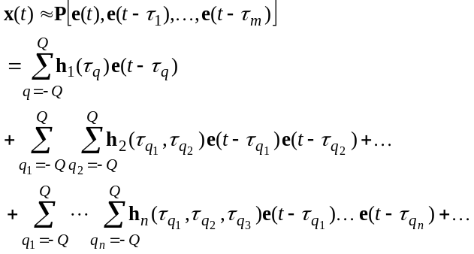 (17)
Assuming continuous time-delayed versions of the input and a memory span tending to infinity, we end up in the conventional time-domain Volterra series form:

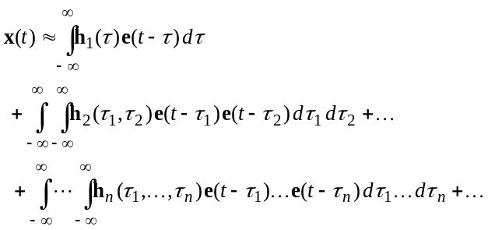
(18)
If now a frequency-domain representation of both x(t) and e(t) were substituted into the n’th-dimensional convolutions of (18) we would obtain the frequency-domain Volterra series representation:

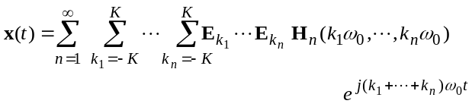
(19)
where the various H_{n}(k₁ω₀,…,k_{n}ω₀) are known as the n’th order Nonlinear Transfer Functions, NLTF’s, and correspond to the n’th-dimensional Fourier transforms of the time-domain n’th order Kernels h_{n}(τ₁,…,τ_{n}):

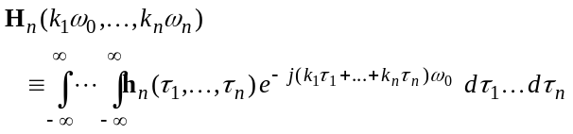
(20)
Expressions (18) and (19) affirm that, expanded in a Volterra series, the system becomes completely identified by its n’th order kernels or nonlinear transfer functions [12], [16]-[18].
Constituting a true analytical model of a nonlinear dynamic system, the main advantage of Volterra series is its ability to provide qualitative information in analytic form, being thus amenable for circuit design.

Returning now to our nonlinear circuit example, we first need to approximate the nonlinearities, q_{NL}[v_{O}(t)] and i_{NL}[v_{O}(t)], by low order polynomial expansions around some quiescent point, (I_{S},V_{O}), [12]. So, the nonlinear charge and current components become:

(21)

and

(22)

which leads to a circuit solution for v_{o}(t) of the form [12]:

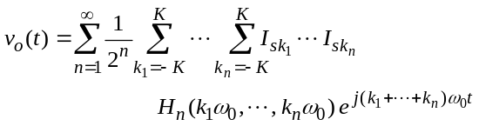 (23)

In its most common form, the polynomial approximation adopted for the Volerra series is the Taylor expansion, for which there is a full set of methods to compute the time-domain kernels and frequency-domain NLTF’s. However, the limited approximation range provided by the Taylor expansion, associated with the excessive labor required by the nonlinear sources method [12], determines that Volterra series is normally restricted to mildly nonlinear circuits described up to 3rd order. Unfortunately, the conditions describing this “mildly nonlinear” behaviour are not clear. As a matter of fact, this is a consequence of the limited range of convergence of this uniform error approximation Volterra series [17], which requires smooth behaviour of the nonlinear function and its derivatives in the whole domain of signal amplitude and memory span. But, even if the function is, in this sense, well behaved, it may still happen that the desired level of accuracy requires a Volterra model with a large number of kernels. In this case, although the mathematical convergence may not be an issue, the practical utility of the Volterra expansion is still questioned. Practical observations have shown that the Volterra formulation has its usefulness restricted to excitation amplitudes much smaller that the quiescent point, for example, comfortably below the circuit’s 1dB compression point [12].

B. Harmonic-Balance
Alternatively, the full nonlinear harmonic-balance equation can be solved for V_{o} using a (2K+1)-dimensional Newton-Raphson algorithm (harmonic-Newton). If the HB equation of (15) is put in the form of:

(24)

the iterative solver creates a succession of solution estimates ⁰V_{o}, ¹V_{o}, ..., ^{i}V_{o}, ^{i+1}V_{o}, ..., ^{f}V_{o}

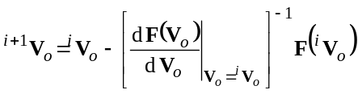 (25)

until ||F(^{f}V_{o})||<ε, where ε is a predefined acceptable error.
The harmonic-Newton is clearly the most used method for microwave circuit simulation. In its most common implementation - Piecewise Harmonic-Newton [4] - the network is divided into two sub-circuits as shown in Fig. 2. One of these sub-circuits is nonlinear and memoryless, while the other is dynamic but necessarily linear. By adding the excitation, this allows the construction of a nodal form of the HB equation:

(26)

where the current entering in the linear sub-network is calculated in the frequency-domain by:

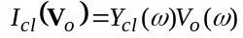 (27)

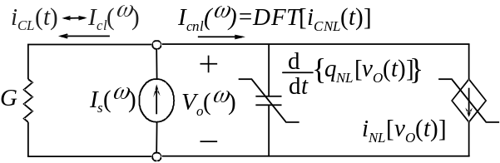
Fig. 2 – Division of the circuit into a nonlinear and a linear sub-networks according to the piece-wise HB implementation.
Unfortunately, direct frequency-domain calculation of the current component entering the nonlinear sub-network is not possible. So, this problem is circumvented by constructing a time-domain representation of voltage (via inverse DFT), computing the current in a time-step by time-step basis, and then converting this time-domain current back again to the frequency-domain (via the DFT). Mathematically, this is computed by:
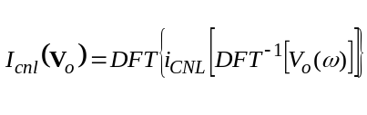 (28)
This approach, known as the mixed-mode HB to distinguish it from implementations entirely working on the frequency domain (see [12], [19] and [20], for example), takes maximum profit of time and frequency-domain representations. As a matter of fact, it uses frequency-domain to solve the convolutions imposed by the dynamic sub-network as simpler products, and time-domain to solve the convolutions that would arise if we tried to compute the spectra of nonlinearities directly in frequency-domain (remember that the basic nonlinear function is the product [11], [17]).
However, this also brings two important restrictions underlying the sub-network separation determined by piecewise HB. First, the use of frequency-domain techniques in the linear sub-network forbids the existence of any source of nonlinearity there. Second, to be efficient, the time-domain computation of the nonlinear current should not involve any memory so that each time-step, v_{O}(t_{k}), can be calculated independently, regardless of its past.
Figure Fig. 3 concludes this discussion by showing a flow-chart of the piecewise harmonic-Newton implementation.
The conventional harmonic-Newton, or some of its newer implementations using quasi-Newton techniques [21], have been successfully applied to a large variety of microwave nonlinear circuits like amplifiers [22] mixers [23] and oscillators [24]. Relying on iterative methods for solving the associated Newton-Raphson linear system [25], they have recently relaxed the necessity of handling large Jacobian matrices, allowing their application to circuits (or systems) involving a huge number of unknowns [21]. These continuous research efforts have turned harmonic-Newton into the most general and reliable analysis technique for RF and microwave circuit simulation.
Nevertheless, the source of HB main advantage constitutes also the reason of its major weakness. The necessity of passing from the time to frequency-domain, and vice-versa, requires the use of the DFT, and so restricts its application to stimuli and responses where this signal processing tool is both valid and efficient. Therefore, this leaves outside true non-commensurate multi-tone (quasi-periodic or aperiodic) signals [12] and strong nonlinear regimes where the DFT requires a very large number of coefficients.

V. Multi-Rate and Hybrid Domain Methods
Multi-rate techniques appeared exactly to ease the difficulties in handling quasi-periodic signals [6], [26], and have gained a strong acceptance in the wireless circuit design area because of the typical two time-rate nature of these modulated RF signals. However, their application is not restricted to this field, but extends to all situations in which the operating regime can be thought as being determined by two or more different time scales. That is the case of RF mixers, but also of analogue samplers or switched-capacitor filters [6]. These methods have indeed revolutionized the way we saw and understood circuit analysis and simulation.
When the excitation is an RF carrier cos(ω₀t) (or a digital sampling clock) modulated by a base-band envelope v_{e}(t) (or a analogue low frequency information signal), which is uncorrelated with the carrier, the circuit behaves as if it had a stimulus dependent on two orthogonal time-scales τ₁ and τ₂:

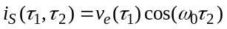 (29)

The original circuit’s ODE, in t shown in (1) becomes a Multi-Rate Partial Differential Equation, MPDE, in these two different time scales (τ₁,τ₂) [6], [10]:

VI. Conclusions
The field of analysis and simulation of microwave/RF circuits has now more thirty years of evolution, but is still interesting from both an engineering and scientific point of view.
Contrary to the traditional SPICE methods, conceived to address the transient response of nonlinear circuits and the steady-state of linear ones, new techniques have been proposed to profit from all the benefits of time and frequency-domain representations. Hence, now a large variety of problems can already be efficiently tackled, ranging from steady-state quasi-periodic regimes, to more complex mutli-rate regimes combining simultaneous transient and steady-state responses.
Although most of these technologies are still confined to the microwave/RF arena, the rapid deployment of devices with multi GHz bandwidths, and the use of signals whose wavelength becomes comparable to the circuit’s dimensions, will determine their spread among (at least) the analogue circuit design engineers.

Acknowledgement
The author is indebted to Prof. Nuno Borges Carvalho for his many valuable contributions, that during the last six years helped grabbing this knowledge and developing some of the reported techniques.

References
[1] L. W. Nagel, SPICE2: A Computer Program to Simulate Semiconductor Circuits, Electronic Research Laboratory, University of California-Berkeley, Memo ERL-M520, 1975.
[2] K. Kundert, J. White, and A. Sangiovanni-Vicentelli, Steady-State Methods for Simulating Analog and Microwave Circuits, Kluwer Academic Pub., Norwell, MA, 1990.
[3] V. Rizzoli and A. Neri, “State of the Art and Present Trends in Nonlinear Microwave CAD Techniques”, IEEE Trans. on Microwave Theory and Tech., Vol. MTT-36, No. 2, pp.343-365, 1988.
[4] M. S. Nakhla and J. Vlach, “A Piecewise Harmonic Balance Technique for Determination of Periodic Response of Nonlinear Systems”, IEEE Trans. on Circuits and Systems, Vol. CAS-23, No. 2, pp.85-91, 1976.
[5] V. Rizzoli, C. Cecchetti and A. Lipparni, “A General-Purpose Program for the Analysis of Nonlinear Microwave Circuits Under Multitone Excitation by Multidimensional Fourier Transform”, 17th European Microwave Conference Proc., pp.635-340, Rome, 1987.
[6] J. Roychowdhury, “Analysing Circuits with Widely Separated Time Scales Using Numerical PDE Methods”, IEEE Trans. on Circuits and Systems - I, Vol. CAS-48, No. 5, pp.578-594, 2001.
[7] E. Ngoya and R. Larchevèque, “Envelop Transient Analysis: A New Method for the Transient and Steady State Analysis of Microwave Communication Circuits and Systems”, 1996 IEEE International Microwave Symposium Dig., pp.1365-1368, San Francisco, 1996.
[8] V. Rizzoli, A. Neri and F. Mastri, “A Modulation-Oriented Piecewise Harmonic Balance Technique Suitable for Transient Analysis and Digitally Modulated Analysis”, 26th European Microwave Conference Proc., pp.546-550, Prague, 1996.
[9] J. C. Pedro and N. B. Carvalho, “Simulation of RF Circuits Driven by Modulated Signals Without Bandwidth Constraints”, 2002 IEEE International Microwave Symposium Dig., Seattle, 2002.
[10] D. Sharrit, “New Method of Analysis of Communication Systems”, IEEE MTT-S Nonlinear CAD Workshop, 1996.
[11] L. Chua, “Nonlinear Circuits”, IEEE Trans. on Circuits and Systems, Vol. CAS-31, No. 1, pp.69-87, 1984.
[12] J. C. Pedro and N. B. Carvalho, Intermodulation Distortion in Microwave and Wireless Circuits, Artech House, Norwood, 2003.
[13] Simulink 5.0, The Mathworks, Inc., 2002.
[14] T. J. Aprille and T. N. Trick, “Steady-State Analysis of Nonlinear Circuits With Periodic Inputs”, Proceedings of the IEEE, Vol. 60, No.1, pp.108-114, 1972.
[15] C. Christoffersen and M. B. Steer, “State-Variable-Based Transient Circuit Simulation Using Wavelets”, IEEE Microwave and Wireless Components Lett., Vol. 11, No. 4, pp.161-163, 2001.
[16] S. A. Maas, Nonlinear Microwave Circuits, Artech House, Norwood, MA, 1988.
[17] M. Schetzen, The Volterra and Wiener Theories of Nonlinear Systems, John Wiley & Sons, New York, 1980.
[18] L. Chua and C. Ng, “Frequency-Domain Analysis of Nonlinear Systems: Formulation of Transfer Functions”, Electronic Circuits & Systems, Vol. 6, pp. 257-269, 1979.
[19] N. B. Carvalho and J. C. Pedro, “Multi-tone Frequency Domain Simulation of Nonlinear Circuits in Large and Small Signal Regimes”, IEEE Trans. on Microwave Theory and Tech., Vol. MTT-46, No. 12, pp.2016-2024, 1998.

[20] C. R. Chang and M. B. Steer, “Frequency-Domain Nonlinear Microwave Circuit simulation Using the Arithmetic Operator Method”, IEEE Trans. on Microwave Theory and Tech., Vol. MTT-38, No. 8, pp.1139-1143, 1990.
[21] V. Rizzoli, F. Mastri, E. Furini and A. Costanzo, “A Krylov-Subspace Technique For The Global Stability Analysis of Large Nonlinear Microwave Circuits”, 2001 IEEE International Microwave Symposium Dig., pp.435-438, 2001.
[22] N. B. Carvalho and J. C. Pedro, “Large and Small Signal IMD Behavior of Microwave Power Amplifiers”, IEEE Trans. on Microwave Theory and Tech., Vol. MTT-47, No. 12, pp.2364-2374, 1999.
[23] N. B. Carvalho and J. C. Pedro, “Analysis and Measurement of Multi-tone Intermodulation Distortion of Microwave Frequency Converters”, 2001 IEEE International Microwave Symposium Dig., pp. 1671-1674, 2001.
[24] V. Rizzoli, A. Costanzo and A. Neri, ”A Novel Substitution Algorithm for the Efficient Analysis and Optimisation of Microwave Oscillators”, 27th European Microwave Conference Proc., Vol. 2, pp.826-831, 1997
[25] Y. Saad and M. H. Schultz, ”GMRES: A Generalized Minimal Residual Method for Solving Nonsymmetric Linear Systems”, SIAM Journal Sci. Stat. Comput., 7, pp. 856-869, 1986.
[26] H. Brachtendorf, G. Welsch, R. Laur and A. Bunse-Gerstner, “Numerical Steady-State Analysis of Electronic Circuits Driven By Multi-Tone Signals”, Electrical Engineering: 79, pp.103-112, 1996.
[27] D. Hente and R. H. Jansen, “Frequency Domain Continuation Method for the Analysis and Stability Investigation of Nonlinear Microwave Circuits”, IEE Proceedings-H Microwaves Antennas and Propagation, Vol. 133, No. 5, pp. 351-362, 1986.
[28] P. J. Rodrigues, Computer Aided Analysis of Nonlinear Microwave Circuits, Artech House, Inc., Norwood, MA, 1998.
[29] J. C. Pedro and N. B. Carvalho, “Efficient Harmonic Balance Computation of Microwave Circuits’ Response to Multi-Tone Spectra”, 29th European Microwave Conference Proc., pp.103-106, Munchen, 1999.
[30] N. Soveiko and M. Nakhla, “Steady State Analysis of Multitone Nonlinear Periodic Circuits in Wavelet Domain”, 2003 IEEE International Microwave Symposium Dig., Philadelphia, 2003.

